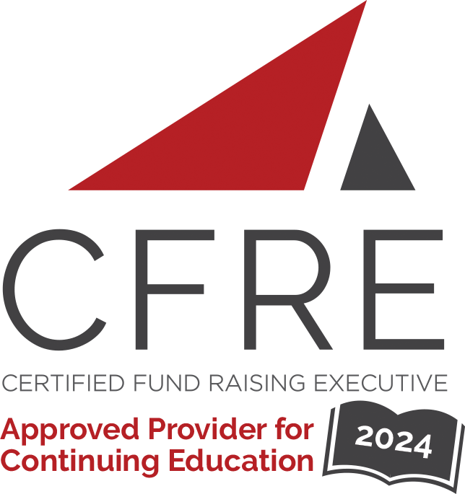  CFRE International has developed this form as a way for you to quickly track (and keep in your files!) the continuing education sessions you have attended. Simply check the boxes next to the sessions you attended. At the end of the conference, add up the total number of hours. Keep this sheet and you will be ready to complete your application form. All of the session slots listed are eligible for continuing education points on your CFRE application for initial certification and/or recertification. Sessions not listed here are not eligible for points. |  | CONTINUING EDUCATION POINTS TRACKER

Activity Organizer: - The 2024 Big 12 Development Conference
Title of Activity: - The 2024 Big 12 Development Conference
Names of Presenter(s): - Various
Dates and Location: - 3-5 June, 2024 – Stillwater, OK USA

Date: 4 June, 2024
Session 1: 8:30am – 9:45am (1.25 pts)
- Opening Remarks & Keynote Speaker Courtland Warren

Date: 4 June, 2024
Session 2: 10:00am – 10:45am (1 pt)
- Hear More from Keynote Courtland Warren
- The Further Evolution of Corporate Partnerships, Stewardships, and Recognition
- Crafting Culture: Developing Organizational Values through Employee Engagement
- Unlocking Fundraising Success: Powering Discovery and Referrals with Goal Motivation
- Student Success Philanthropy and the Evolving Structure of University Foundations
- Empowering Philanthropy: The Impact and Engagement of Women in Fundraising

Date: 4 June, 2024
Session 3: 1:45pm - 2:30pm (1 pt)
- Building the Bench: Development Associates and Digital Experience Officers
- Combining Forces to Create Dynamic Unit Events in Territories
- Synergetic Success: Fundraising in Tandem with Deans
- Elevating Talent and Advancing the Organization through the Innovation Council
- Unlocking Fundraising Potential in a Competitive Landscape
- When You Die, Can We Have Your Money?

Date: 5 June, 2024
Session 4: 8:30am – 10:30am (2 pts)
- Closing Remarks & Keynote Speaker

Date: 5 June, 2024
Session 5: 10:45am – 11:30am (1 pt)
- Mentorship and its Impact on the Professional Experience of Advancement Employees at the University of Colorado Boulder
- Harmonizing Pipeline Propulsion Across Development Teams
- Harnessing AI for Advancement: A University of Utah Perspective
- Connect, Achieve, Succeed! Working Together to Build Meaningful Relationships Amidst Significant Leadership Transitions
- Visionary Philanthropy in Action
- A Legacy in Land: Facilitating Real Estate Gifts by Agricultural Landowners

Date: 5 June, 2024
Session 6: 11:45am – 12:30pm (1 pt)
- Onboarding the K-State Way: The Good, the Bad, and the Beautiful Lessons Learned
- Fundraising for Strategic Initiatives: The First Steps
- 5 Steps for Building Portfolios, Finding Filler Visits and Closing Transformational Gifts with EverTrue and Oklahoma State
- Parent and Family Philanthropy from the Ground Up
- Journey to Support: Strategic Trip Planning and Best Practices for Getting More Visits in Healthcare Development
- Managing Ethical Issues in Planned Giving

Total number of points attained: __________

